DESCENDING ORDER

# EXP NO: 11

## AIM:

## To compute descending order of an array using 8085 processor.

## ALGORITHM: 1. Initialize HL pair as memory pointer. 2. Get the count at memory and load it into C register 3. Copy it in D register (for bubble sort (N-1)) times required). 4. Get the first value in A register. 5. Compare it with the value at next location. 6. If they are out of order, exchange the contents of A register and memory. 7. Decrement D register content by 1 8. Repeat step 5 and 7 till the value in D register become zero. 9.  Decrement the C register content by 1. 10.  Repeat steps 3 to 9 till the value in C register becomes zero.

PROGRAM:  
 LOOP: LXI H,3500  
 MVI D,00  
 MVI C,05  
 LOOP1: MOV A,M  
 INX H  
 CMP M  
 JNC LOOP2  
 MOV B,M  
 MOV M,A  
 DCX H  
 MOV M,B  
 INX H  
 MVI D,01  
 LOOP2: DCR C  
 JNZ LOOP1  
 MOV A,D  
 RRC  
 JC LOOP  
 HLT

## INPUT:

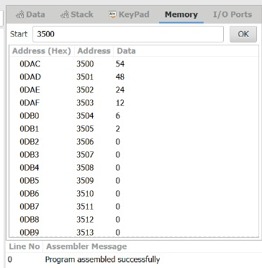

## OUTPUT:

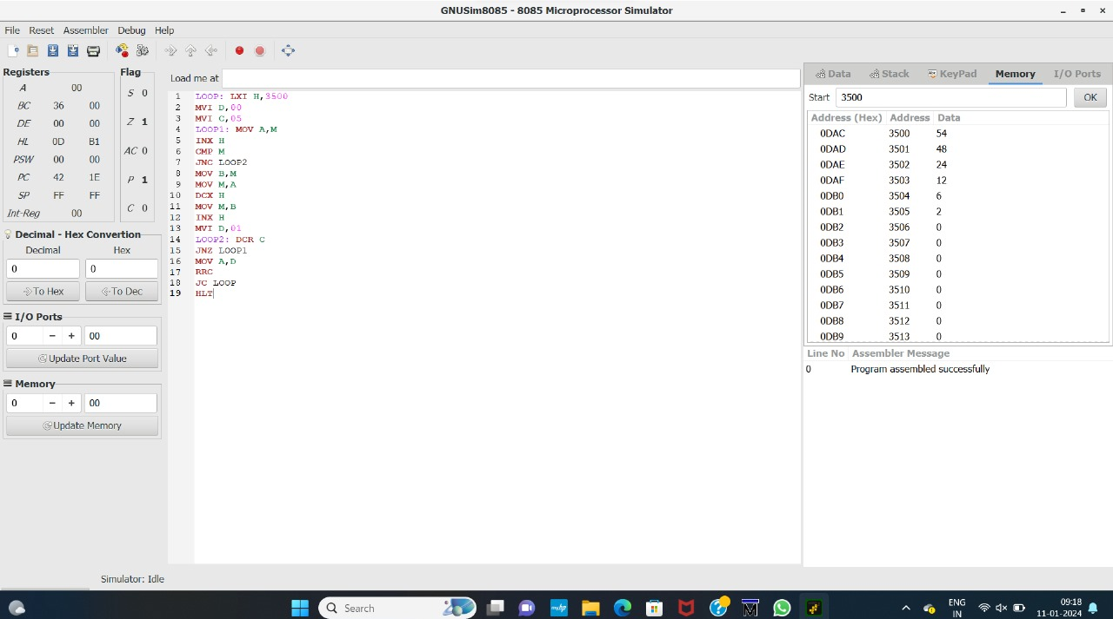

## RESULT:

Thus the program was executed successfully using 8085 processor stimulator.